**DAY-28**

**SpringBoot Code Pipeline**

1. Git Hub repo create

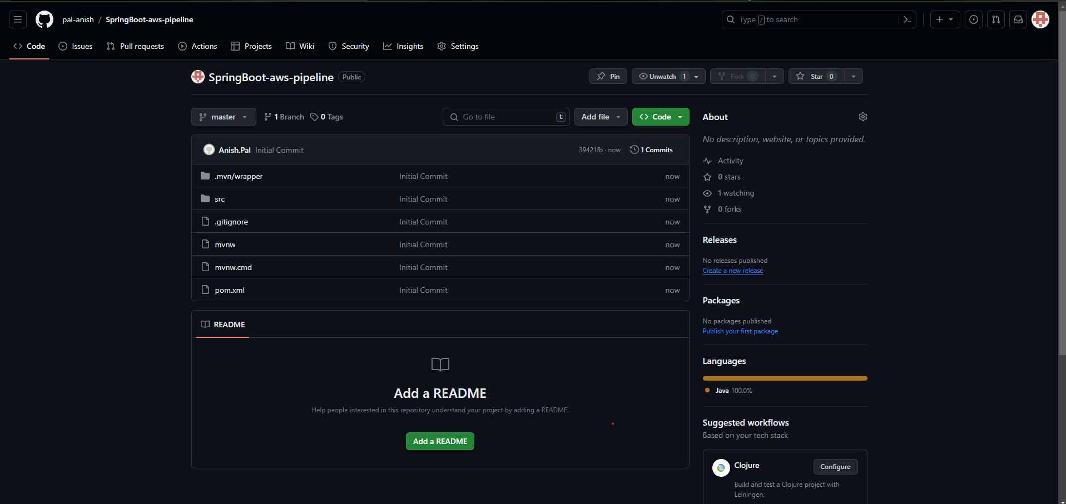

1. Go to GitHub Action

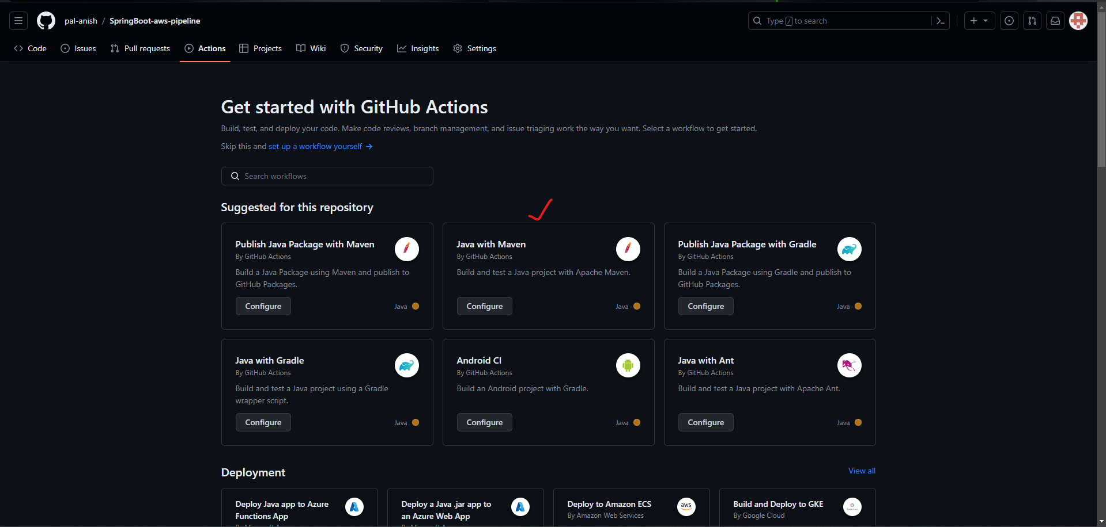

1. Configure settings and commit changes

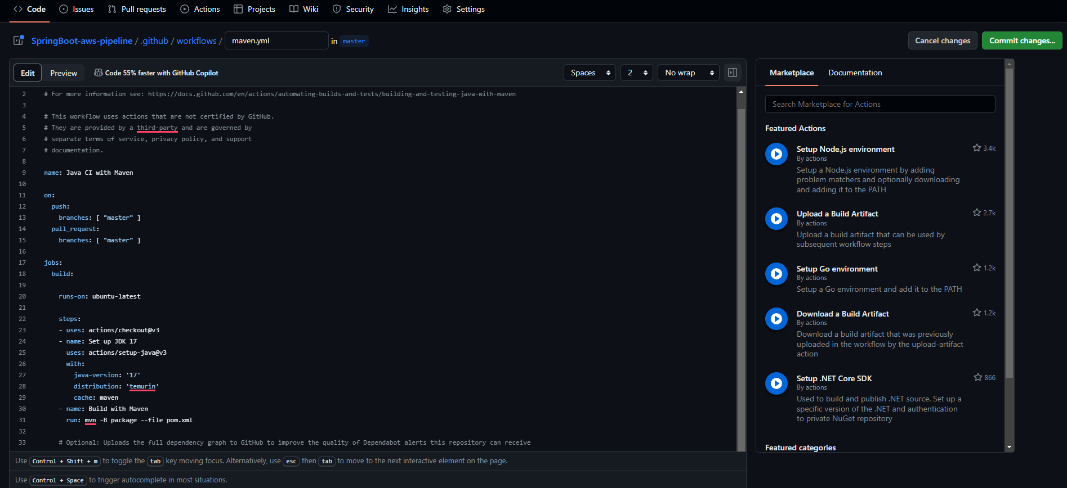

1. Git hub Repo Settings Configure

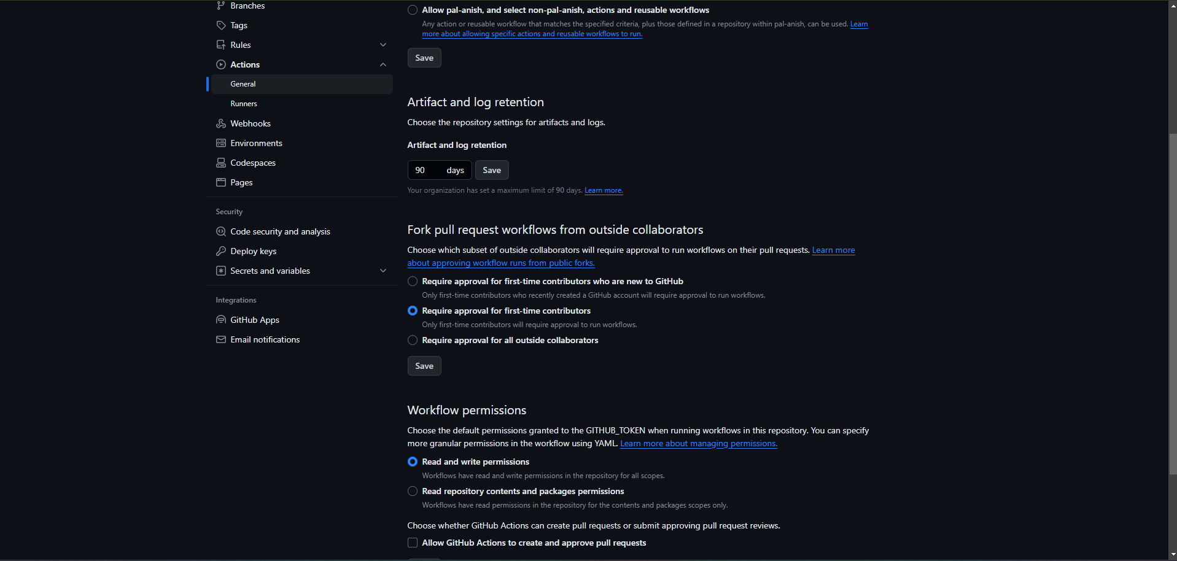

1. First Build

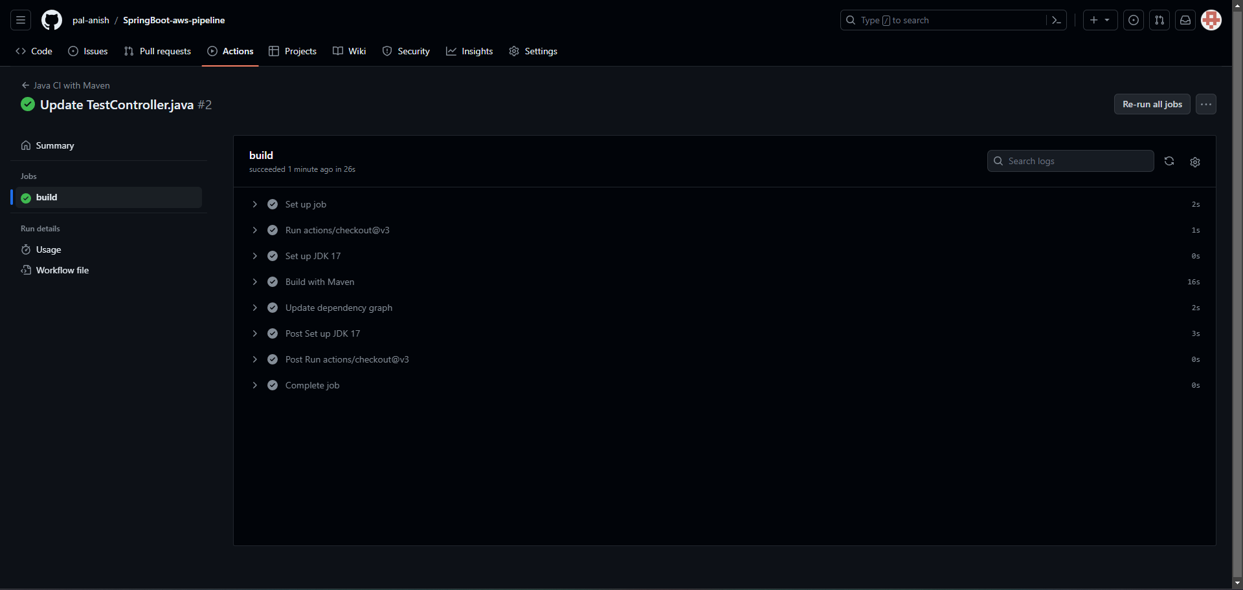

1. Commited Some Changes Added new endpoint so again Build Started

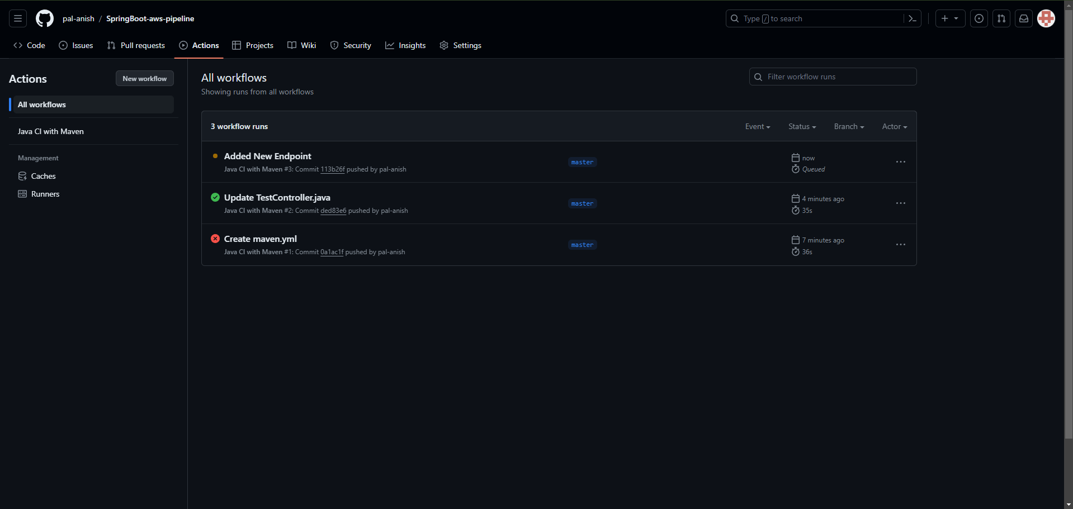

1. Post Build

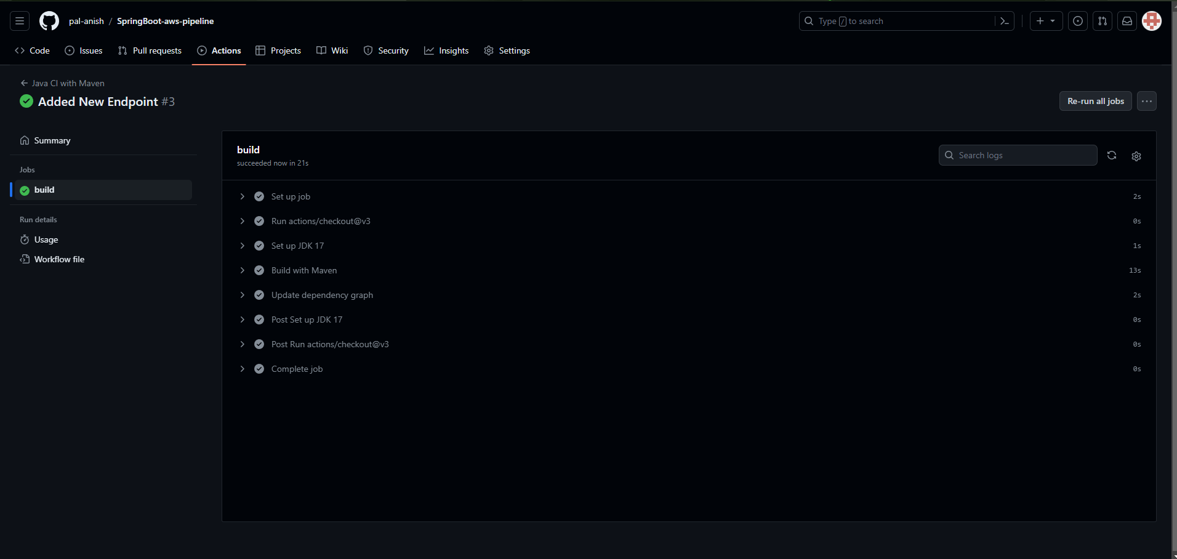

1. Integrate maven.yml for Automated Build and Test. CICD Pipeline

